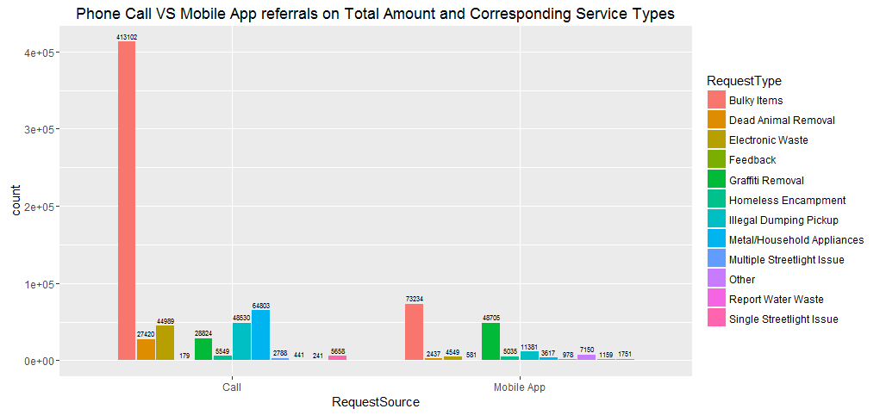

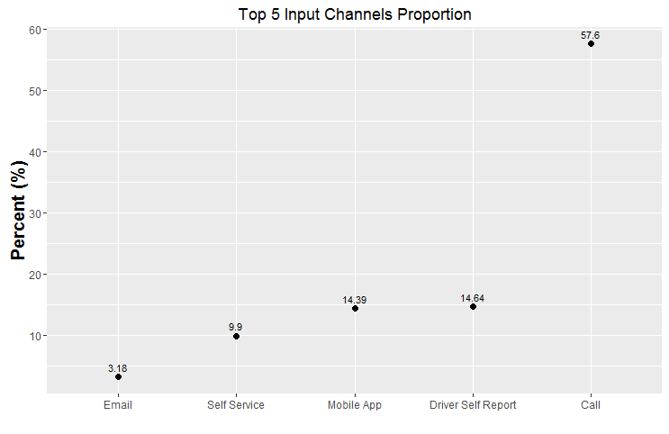

From the charts above, the requests by call (57.6%) are much more than any other input channels including Mobile App (14.39%). In the request source of call, requests for the services of Bulky Items account for majority of the total requests, followed by the requests for Metal/Household Appliances, Illegal Dumping Pickup, and Electronic Waste. However, in the request source of Mobile App, although the requests for Bulky Items take the leader place, the requests of Graffiti Removal come quite close to the requests for Bulky items. To conclude, in such a contemporary digital world, compared to the Call, requesting by mobile app is still relatively at a low level, indicating the necessity of increasing digital presence of 311. Secondly, we can add a special call line for bulky item service to increase efficiency, while in the mobile app we can add the distinctive buttons for the bulky items and graffiti Removal services.

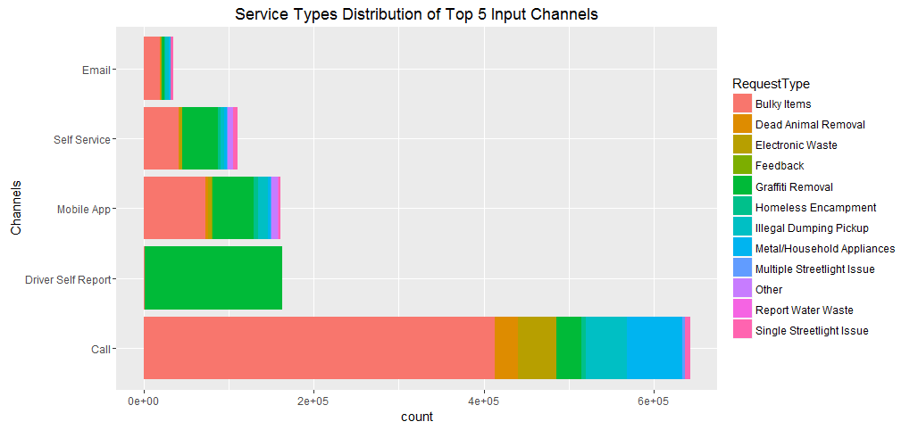

From all input channels, I choose the top 5 channels on the volume of requests. Besides call and mobile app which are mentioned before, the volume of requests by Driver Self Report, Self Service and Email are in the second, fourth and fifth place separately. It is astonishing and worth thinking that almost all requests by the Driver Self Report are to ask for the Graffiti Removal, while for the other input channels the service types of Bulky Items, Graffiti Removal and Metal/Household Appliances are the most popular ones people requested for, especially for the bulky items. Therefore, the graffiti removal requests are extremely high in the request by Driver Self Report, and the polices should attach great importance to this serious problem about graffiti on cars and do some special rectification regularly. Besides, for the other four channels, it is also necessary to set special groups focusing on the service types of Bulky Items, Graffiti Removal and Metal/Household Appliances.

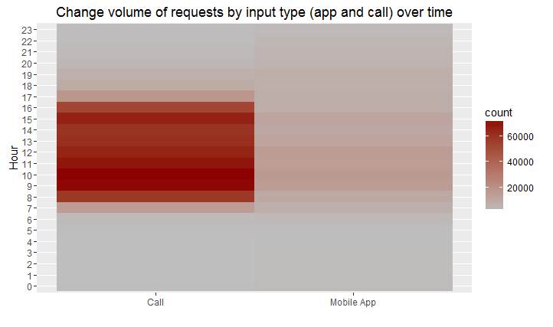

From the graph above, we can see that the time duration of request by Call and App is mainly from 7am to 7pm, with extremely high volumes of requests by Call comparatively to Mobile App.

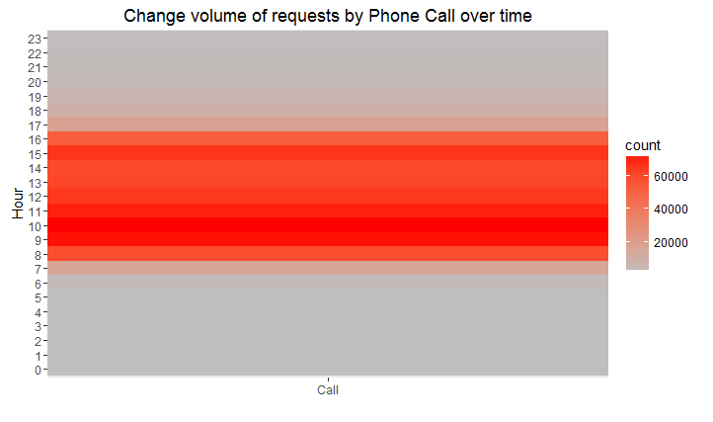

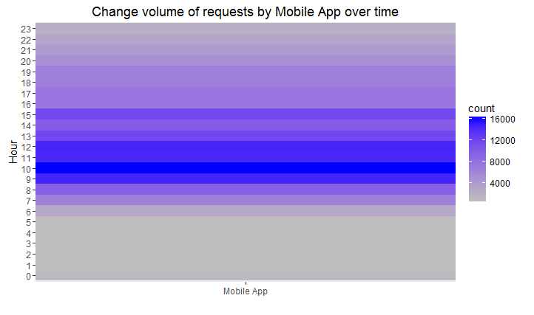

Specifically speaking, the peaks of service requests by phone call are around 9am to 10am during which the request amounts are as high as more than 60000 calls/hour, and around 15am at which the requests are comparatively lower but also very high near 50000 calls/hour. However, the peak of requests by mobile app is mainly at around 10am, with an amount of more than 16000 requests per hour. Therefore, to increase the departments’ efficiency, it is recommended that the Call Service department should deploy more employees at around 9am to 10am and 15am. Besides, mobile app service department should also deploy more employees and give more attention on the time duration around 10am, and try to gather the valuable data. On the other hand, the police departments should also make corresponding adjustments in these busy time periods and make reasonable arrangements for the number of polices on duty in the different time periods.